Capstone Task Day 02
Name: Ibrahim Shnouda
Group: IoT701-A
Facilitator: Eng.Ehab Elsayed
------------------------------------------------------------------------------------------------------

Task:

1.$ echo "polling sensor" sleep 200 &
2.$ ps aux | grep <PID>
3.$ netstat -t
4.$ sleep 100
$ fg <%job number>
5.$ kill -9 <PID>

Screenshot:
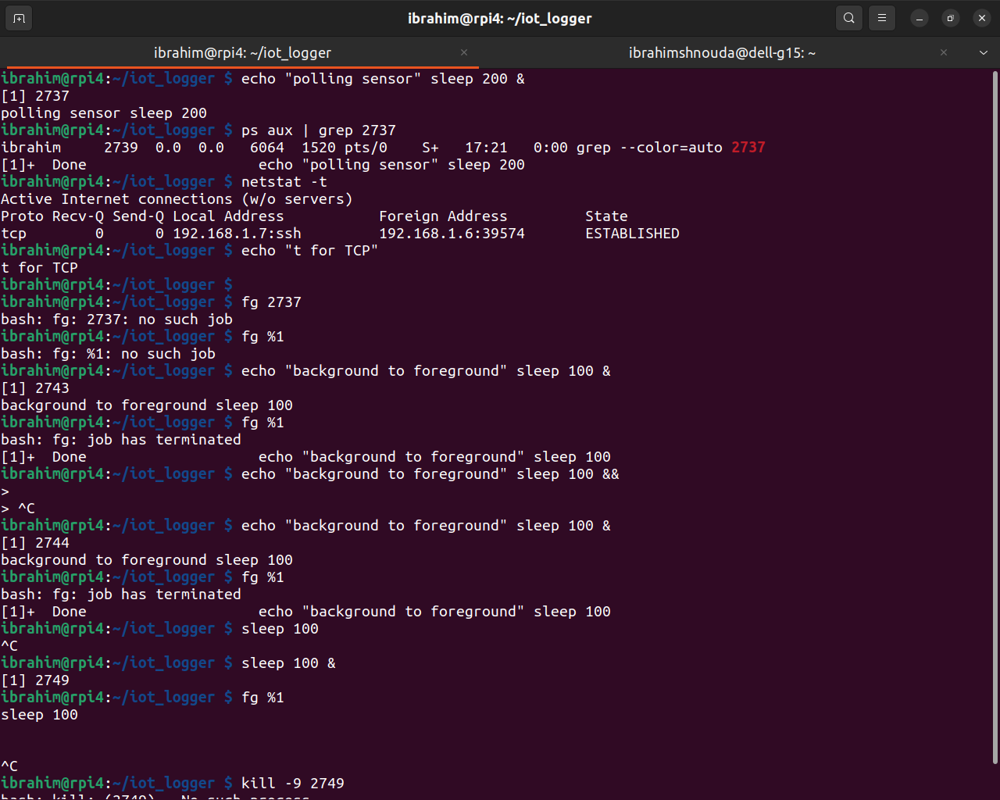

Open-Ended Questions:

1.shell parsing your prompt and the first argument (program) execute as child process to bash process using (fork()) System call and if this program need to options uses options the print output to terminal or file dependent on file descriptor.

2.Daemon, Orphan, and Zombie
2.1.Daemon Process: Process ruining in the background without any GUI
ps -ef | grep daemon

2.2.Orphan Process: is a process their parent dead or terminated and become with no parent, new parent will be systemd or init process
ps -ef | grep <PID> if PPID = 1 : this orphan process

2.3.Zombie process: is a process their parent don’t use wait() syscall to take child process status then terminate after done, process Is not killed after finishing
ps aux | grep 'Z'

3.IPC is the way to allow processes to communicate to each other while running like pipes(|) to share date and memory sharing and sockets .

